Nocturnal wandering in the elderly: cross-sectional and longitudinal analysis of predictors

Soutrik BANERJEE, MD, PhD,
Web: http://www.linkedin.com/pub/soutrik-banerjee/4/75b/47a

TABLE OF CONTENTS

1 Key information 7
2 Analysis plan 8
3 Cross-sectional analysis (GLM) 10
4 Longitudinal analysis 13
4.1 Marginal model (GEE) 13
4.2 Hierarchical or random-effects model (GLMM) 16
5 Comparison of two subpopulations with and without depressed status 26
6 Appendix 27
7 Conclusion 46
8 Bayesian analysis using MCMC sampling 47

LIST OF TABLES

Table 3-1. Parameter estimates for the cross-sectional analysis with mean nocturnal activity as outcome; N = 33 10
Table 4-1. Parameter estimates for the GEE analysis with nocturnal activity as outcome; N = 33 13
Table 4-2. Parameter estimates for the GLMM analysis by NUMERCIAL INTEGRATION method with nocturnal activity as outcome; N = 33 16
Table 4-3. Parameter estimates for the GLMM analysis by LINEARISATION method with nocturnal activity as outcome; N = 33 20
Table 4-4. Parameter estimates by random splines method with nocturnal activity as outcome; N = 33 22
Table 6-1. Demographic & clinical characteristics of the sample population by exposure group; N = 33 27
Table 6-2 shows the posterior probabilities and parameter estimates of a 2-component Gaussian mixture analysis using the R-packages FlexMix (or Mclust), CAMAN & mixtools, & WinBUGS for the cross-sectional analysis 41
Table 6-3 shows the posterior probabilities and parameter estimates of a 4-component Gaussian mixture analysis using the R-package FlexMix for the longitudinal analysis 44
Table 8-1. Parameter estimates for the cross-sectional analysis with mean nocturnal activity as outcome; N = 33 47
Table 8-2. Parameter estimates for the cross-sectional analysis with mean nocturnal activity as outcome; N = 33 48
Table 8-3. Parameter estimates for the GLMM analysis by NUMERCIAL INTEGRATION method with nocturnal activity as outcome; N = 33 49
Table 8-4. Parameter estimates for the GLMM analysis by NUMERCIAL INTEGRATION method with nocturnal activity as outcome; N = 33 50

LIST OF FIGURES

Figure 3-1 shows the 3-D relation between ADL, cognitive status and mean nocturnal activity 11
Figure 3-2 shows the interaction ‘depressed status X cognitive status’ 12
Figure 4-1 shows predicted mean (GEE) nocturnal activity (95% CI) by ‘depressed status X cognitive status’ 14
Figure 4-2 shows predicted mean (GEE) nocturnal activity (95% CI) by cognitive status 15
Figure 4-3 shows predicted mean (GLMM) nocturnal activity (95% CI) by ‘depressed status X cognitive status’ 18
Figure 4-4 shows predicted mean (GLMM) nocturnal activity (95% CI) by cognitive status 19
Figure 4-5 shows predicted mean (random splines) nocturnal activity (95% CI) by ‘depressed status X cognitive status’ 24
Figure 4-6 shows predicted mean (random splines) nocturnal activity (95% CI) by cognitive status 25
Figure 6-1 shows model fit graphs for the cross-sectional analysis 29
Figure 6-2 shows covariates’ effects plots for the cross-sectional analysis 30
Figure 6-3 shows scatterplot matrix between ADL, MMSE and mean nocturnal activity for the cross-sectional analysis 31
Figure 6-4 shows boxplots of observed nocturnal activity by different groups for the cross-sectional analysis 32
Figure 6-5 shows night1 – night8 scatterplot matrix of observed nocturnal activity for the longitudinal analysis 33
Figure 6-6 shows the evolution of individual observations (after standardising) over 8 nights for the longitudinal analysis 34
Figure 6-7 shows the boxplots of observed nocturnal activity by cognitive status over 8 nights for the longitudinal analysis 35
Figure 6-8 shows the average (95% CI) observed evolution by ‘depressed status X cognitive status’ for the longitudinal analysis 36
Figure 6-9 shows the average (95% CI) observed evolution by cognitive status for the longitudinal analysis 37
Figure 6-10 shows the qqplot (95% CI) of empirical Bayes (random-intercept) estimates for the longitudinal analysis 38
Figure 6-11 shows night1 – night8 scatterplot matrix of residuals (random-intercept) for the longitudinal analysis 39
Figure 6-12 shows the boxplots of residuals (random-intercept) by cognitive status over 8 nights for the longitudinal analysis 40
Figure 6-13 shows the histogram of mean nocturnal activity (seconds) overlaid with two 2-component Gaussian finite mixture models using the R-packages FlexMix, Mclust, CAMAN & mixtools, & WinBUGS for the cross-sectional analysis 43
Figure 6-14 shows the histogram of nocturnal activity (seconds) overlaid with 4-component Gaussian finite mixture models using the R-package FlexMix and smoothed kernel density for the longitudinal analysis 44
Figure 6-15 shows the predicted probability of being a ‘pacer’ to a ‘non-pacer’ by ADL for the cross-sectional analysis 45
Figure 8-1 shows simulated gamma PDFs and CDFs of the full data (N = 45) by two exposure groups, respectively for the cross-sectional analysis 51
Figure 8-2 shows the posterior parameter distributions (gamma) and posterior predictive distributions (negative binomial) of the full data (N = 45) by two exposure groups, respectively for the cross-sectional analysis 52
Figure 8-3 shows the posterior density of a mixture of 2 normal distributions using MCMC with the R-package mixAK for the cross-sectional analysis 53

LIST OF ABBREVIATIONS

AD | Alzheimer’s disease
ADL | activities of daily living
AICc | corrected Akaike information criterion
BIC | Bayesian information criterion
BGR | Brooks-Gelman-Rubin
CAMAN | computer assisted mixture analysis
CI | confidence interval
CrI | credible interval
CDF | cumulative density function
DF | degrees of freedom
DIC | deviance information criterion
EM | expectation maximisation
GDS | geriatric depression score
GEE | generalised estimating equations
GLM | generalised linear model
GLMM | generalised linear mixed model
GOF | goodness of fit
MCMC | Markov chain Monte Carlo
MMSE | mini-mental state score
OR | odds ratio
pD | no. of effective parameters
PIRS | passive infra-red sensor
PDF | probability density function
SD | standard deviation
SE | standard error
VEM | variational expectation maximisation

Key information

- Sample size or N = 33 subjects; 11 subjects without depressed status variable were not analysed.
- Outcome:
- ‘Mean Nocturnal Activity’ over 8 nights (cross-sectional analysis).
- ‘Nocturnal Activity’ measured repeatedly for 8 nights (longitudinal analysis).
- Exclusive inpatient movements detected by 8 PIRSs placed at a height of 2-3 m above the ground in two 3 x 3 m² patient bedrooms at the university hospital in Grenoble, France, between 00:00 and 06:00 hours, expressed in seconds as total (cumulative) nocturnal activity including bed, toilet and room activity.
- Exposure variable: two groups consisting of ‘normal cognitive function’ and ‘cognitively impaired’ obtained by categorising MMSE score (0-30) with cut-off 24/25; named as cognitive status in this analysis.
- Covariates selected in the final stage of analysis:
- ADL score (continuous, 0-6).
- Depressed status (yes / no) obtained by categorising the GDS score (0-30) with cut-of 14/15.
- Nights (in longitudinal analysis only).
- Interactions (depressed status x cognitive status).
- Covariates not considered in the final stage of analysis: antidepressants, hypnotics, neuroleptics, weight, prosthesis, continence, because they were not significant in preliminary regression analysis using backward selection as well as in univariate analysis.
- Data were pooled from two researchers (Soutrik, N = 21 and Gina, N = 12); the covariate ‘researcher’ was not a significant covariate as well.
- Approach to missing data (for the outcome measures only): approximately, 6% of data were missing, for which mean values for the remaining nights were imputed in the longitudinal analysis.
- All analyses presented were carried out with SAS® 9.1.3 (SAS Inc., Cary, NC, USA), R 2.9.0 (CRAN) and WinBUGS 1.4.3.

Analysis plan

- Cross-sectional (GLM):-
- Table:-
- Gamma model
- Negative binomial model ≈ gamma model
- Poisson model → overdispersion (i.e., not good)
- Graph:-
- SAS / R spline-smoothed 3-D (gamma model)
- Interaction* graph (gamma model)
- Longitudinal:-
- Marginal (GEE) model:-
- Table:-
- Gamma model
- Negative binomial model → did not “converge”
- Poisson model → overdispersion (i.e., not good)
- Graph:-
- By 4 level interaction* graph (gamma model)
- By cognitive status (gamma model)
- Hierarchical or random-effects (GLMM) model:-
- Table:-
- Gamma model by numerical integration (random intercept) → did not “converge”
- Negative binomial model by numerical integration (random intercept)
- Poisson model by numerical integration (random slope) → overdispersion (i.e., not good)
- Gamma model by linearisation (random intercept)
- Negative binomial model by linearisation (random intercept) ≈ gamma model
- Poisson model by linearisation (random slope) → overdispersion (i.e., not good)
- Gamma model (random splines) → did not “converge”
- Negative binomial model (random splines)
- Poisson model (random splines) → overdispersion (i.e., not good)
Note: Random splines are not GLMM, although carried out with the GLIMMIX procedure
- Graph:-
- By 4 level interaction* graph (negative binomial model)
- By cognitive status (negative binomial model)
- By 4 level interaction* graph (negative binomial random splines model)
- By cognitive status (negative binomial random splines model)
* Interaction = depressed status X cognitive status

Note: the interactions tested individually, one-by-one due to low statistical power, but are not significant in this analyses:-
- Cross-sectional analysis:-
- ADL X depressed status
- ADL X cognitive status
- ADL X depressed status X cognitive status

- Longitudinal (GEE / GLMM):-
- ADL X depressed status
- ADL X cognitive status
- ADL X depressed status X cognitive status
- Night X ADL
- Night X depressed status
- Night X cognitive status
- Night X depressed status X cognitive status
- Night X ADL X depressed status
- Night X ADL X cognitive status
- Night X ADL X depressed status X cognitive status

Cross-sectional analysis (GLM)

Table 3-1. Parameter estimates for the cross-sectional analysis with mean nocturnal activity as outcome; N = 33
Characteristic | Gamma model |  |  | Negative binomial model
Characteristic | Exponentiated estimates | 95% CI | P-value | Exponentiated estimates | 95% CI | P-value
Cognitive status  Cognitively impaired  Normal | 4.3  1.0 (referent) | 1.7-10.9 | <0.01 | 4.3  1.0 (referent) | 1.7-10.9 | <0.01
Depressed status  Yes  No | 3.1  1.0 (referent) | 1.1-8.8 | 0.03 | 3.1  1.0 (referent) | 1.1-8.8 | 0.03
ADL | 0.8 | 0.6-1.0 | 0.02 | 0.8 | 0.6-1.0 | 0.02
‘Depressed X cognitive’ status | 0.3 | 0.1-0.8 | 0.02 | 0.3 | 0.1-0.8 | 0.02
Scale / dispersion parameter | 1.8 | 1.2-2.8 | na | 0.6 | 0.3-0.8 | na
GOF (value / DF) | 0.7 |  |  | 1.3
Note: scale / dispersion parameter is not exponentiated; values are rounded-off to one decimal value

- Mean nocturnal activity is 4.3 times elevated in the cognitively impaired group w.r.t. the normal cognitive function group.
- Mean nocturnal activity is 3.1 times elevated in the depressed w.r.t. the non-depressed.
- However, the exponentiated interaction < 1, meaning that being depressed causes paradoxically decreased mean nocturnal activity in the cognitively impaired group.
- Mean nocturnal activity decreases with disability (ADL), i.e., 20% decrease with each unit rise in ADL score.
- Although the (exponentiated) parameter estimates (95% CI) of the two models are very close, the GOF in the gamma model is better, which is our reference model for this analysis.
- Both models show significant heterogeneity (scale / dispersion) parameter (> 1), which points towards a mean-variance relationship (variance increasing with mean).
- Poisson / quasi-Poisson model parameter estimates are not shown; the Poisson model had significant overdispersion (poor GOF).
- No significant multicollinearity, outlier, or influential observation was noted.

Figure 3-1 shows the 3-D relation between ADL, cognitive status and mean nocturnal activity
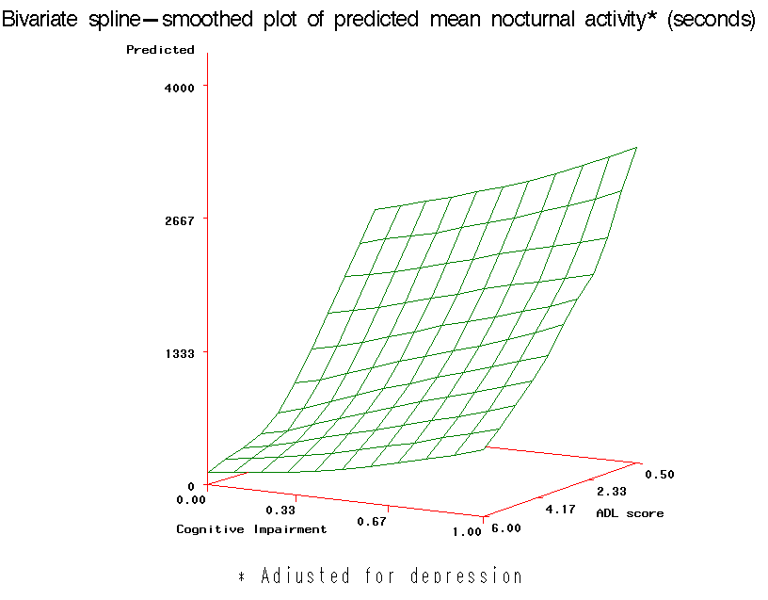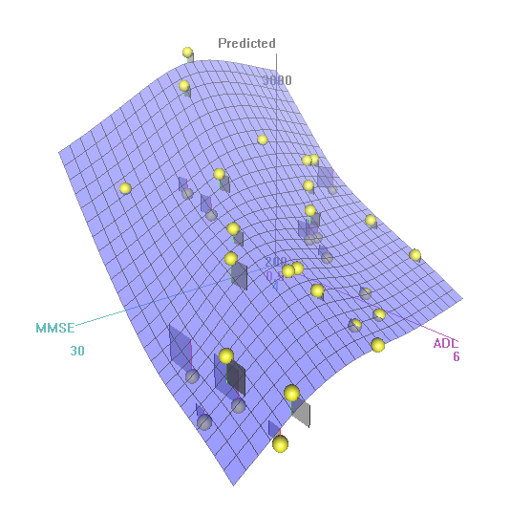

- Figures show the relative importance of disability (ADL) and cognitive status w.r.t. predicted mean nocturnal activity, with disability having more pronounced effect than cognitive status.
- Figures are adjusted for the depressed status and the interaction ‘depressed status X cognitive status’.
- The yellow balls represent the squared residuals.

Figure 3-2 shows the interaction ‘depressed status X cognitive status’
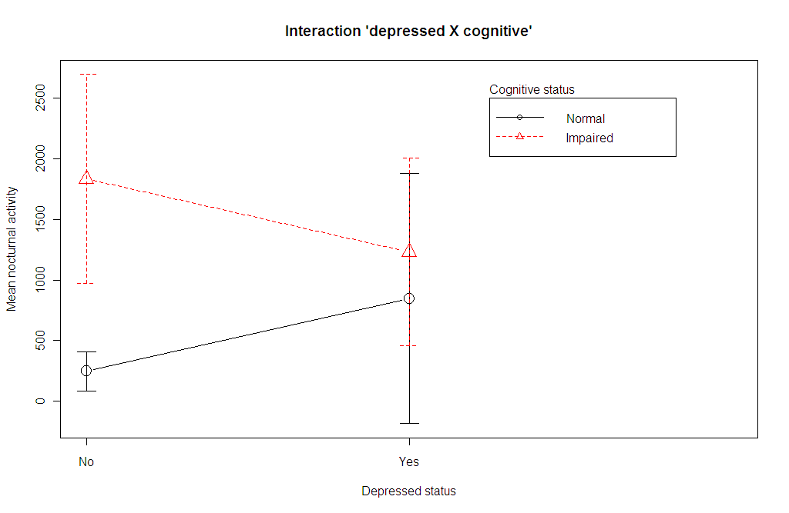

Longitudinal analysis

Marginal model (GEE)

Table 4-2. Parameter estimates for the GEE analysis with nocturnal activity as outcome; N = 33
Characteristic | Gamma model  (empirical; exchangeable working correlation) |  |  | Poisson model  (empirical; exchangeable working correlation)
Characteristic | Exponentiated estimates | 95% CI | P-value | Exponentiated estimates | 95% CI | P-value
Night | 1.0 | 0.97-1.03 | 0.94 | 0.98 | 0.96-1.01 | 0.25
Cognitive status  Cognitively impaired  Normal | 4.1  1.0 (referent) | 2.1-8.0 | <0.01 | 4.7  1.0 (referent) | 2.4-9.3 | <0.01
Depressed status  Yes  No | 3.5  1.0 (referent) | 1.7-7.2 | <0.01 | 2.8  1.0 (referent) | 1.1-7.4 | 0.04
ADL | 0.8 | 0.7-0.9 | <0.01 | 0.8 | 0.7-0.9 | <0.01
‘Depressed X cognitive’ status | 0.3 | 0.1-0.7 | <0.01 | 0.3 | 0.1-1.0 | 0.05
Correlation | 0.4 |  |  | 0.4
GOF (value / DF) | 1.1 |  |  | 1350.2
Note: correlation coefficient is not exponentiated; values are rounded-off to one decimal value (except night)

- Night (time) variable is not significant.
- Poisson model is kept only for comparison; it points towards a significantly high overdispersion owing to its poor GOF.
- Quasi-Poisson model is not shown here.
- Negative binomial model did not converge.
- As model-based CIs differed, only empirical (‘sandwich’) estimates are presented.
- Exchangeable (or compound symmetry) working correlation estimates are shown here; other working correlation estimates (independence, autoregressive and unstructured) are not shown, which are very similar.
- In the non-depressed, cognitively impaired patients had 4.3 (2.2-8.7, 95% CI; p <0.01) higher mean nocturnal activity than normal patients; whereas in the depressed, cognitively impaired patients had 1.1 (0.5-2.5, 95% CI; p = 0.87) times higher mean nocturnal activity than normal patients, which was not significantly different at all.

Figure 4-3 shows predicted mean (GEE) nocturnal activity (95% CI) by ‘depressed status X cognitive status’
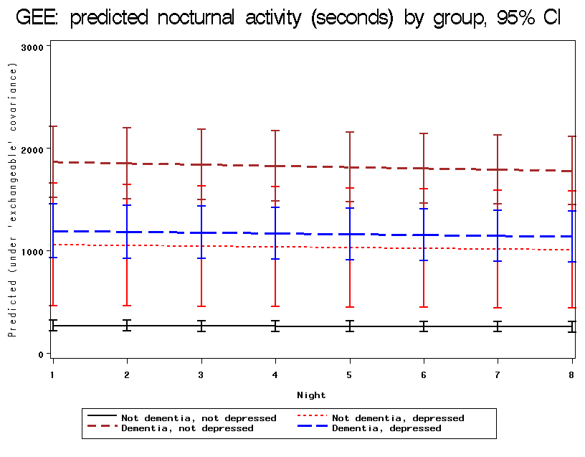

- ‘Dementia’ / ‘Not dementia’ in the legend is to denote the groups, ‘cognitively impaired’ / ‘normal cognitive function’, respectively.

Figure 4-4 shows predicted mean (GEE) nocturnal activity (95% CI) by cognitive status
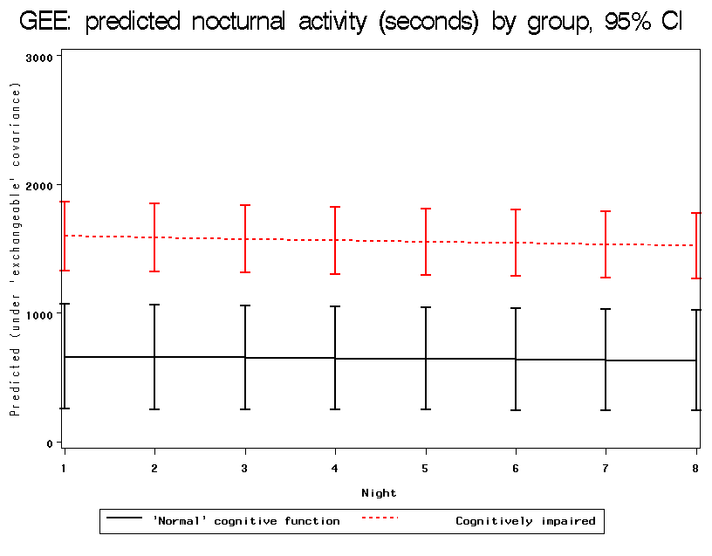

Hierarchical or random-effects model (GLMM)

Table 4-3. Parameter estimates for the GLMM analysis by NUMERCIAL INTEGRATION method with nocturnal activity as outcome; N = 33
Characteristic | Negative binomial (random intercept) model |  |  | Poisson (random slope) model
Characteristic | Exponen. estimates | 95% CI | P-value | Exponen. estimates | 95% CI | P-value
Fixed-effects
Night | 0.99 | 0.92-1.06 | 0.80 | 0.99 | 0.96-1.02 | 0.60
Cognitive status  Cognitively impaired  Normal | 3.4  1.0 (referent) | 1.3-9.4 | 0.02 | 3.4  1.0 (referent) | 1.2-9.4 | 0.02
Depressed status  Yes  No | 2.6  1.0 (referent) | 0.8-8.5 | 0.10 | 2.6  1.0 (referent) | 0.7-8.8 | 0.13
ADL | 0.8 | 0.6-1.0 | 0.02 | 0.8 | 0.6-1.0 | 0.04
‘Depressed X cognitive’ status | 0.3 | 0.1-1.3 | 0.10 | 0.3 | 0.1-1.3 | 0.12
Dispersion parameter | 0.7 | 0.6-0.8 | <0.01
Random-effects
Intercept variance | 0.456 | 0.125-0.788 | <0.01 | 0.822 | 0.388-1.256 | <0.01
Intercept-slope covariance |  |  |  | -0.035 | -0.069-4.1E-04 | 0.05
Slope variance |  |  |  | 0.008 | 0.004-0.012 | <0.01
Note: dispersion parameter and random-effects’ variance estimates are not exponentiated; values are rounded-off to one decimal value (except night and random-effects’ variance estimates)

- Night (time) variable is not significant.
- Poisson model is kept only for comparison (AICc very high compared to the negative binomial model).
- Numerical integration using adaptive Gaussian quadrature of 25 grid points was employed to estimate the parameters.
- Gamma model did not converge.
- Mean (fixed-effects) estimates here are lower than those of the GEE model, although the CIs are wider; in addition, the interpretation of the GEE and GLMM models are different, i.e., the former gives population averaged parameter estimates, whereas the latter provides interpretation at the individual level. Whenever a marginal model is fitted, one directly obtains estimates and inferences for the components of the marginal regression vector that models the average trend in the population (cf. Molenberghs). In case a random-effects model is fitted, one should realise that, even when estimation and inference is based on likelihood principles for the marginal likelihood where the random effects have been integrated out, the parameters keep their original random-effects interpretation. But it should be emphasised that, in GLMM in general, the average trend E(Y_{ij}) is not of the same parametric form as the expectation of the conditional means E[E(Y_{ij}|b_{i})]. Hence, the averaging over the random effects will not yield formal estimates for the elements of the marginal regression vector.
- In contrast to the GEE model, the Poisson and negative binomial fixed parameter estimates are very similar in these two models; however the interpretation of the two models are different, meaning that the former model allows variable subject-specific evolution (slope) in addition to baseline subject-specific random variability, whereas in the latter model, patients are assumed to only differ at baseline and evolve in a parallel manner. In this particular case in the negative binomial model, the random slope variability can be said to be ‘absorbed’ or ‘taken up’ by the fixed dispersion parameter, which is in accordance with the ‘Bayesian’ gamma-Poisson model, where random-effects are integrated out to obtain the negative binomial distribution marginally (cf. Agresti). It must be noted the ‘marginalised’ hierarchical negative binomial model still has some ‘residual’ random-intercept variability.
- Residuals are a bit left skewed with no correlation between time-points (Figure 6-18).
- In conclusion, we explored nocturnal wandering in dementia, depression and disability in this study.

Figure 4-5 shows predicted mean (GLMM) nocturnal activity (95% CI) by ‘depressed status X cognitive status’
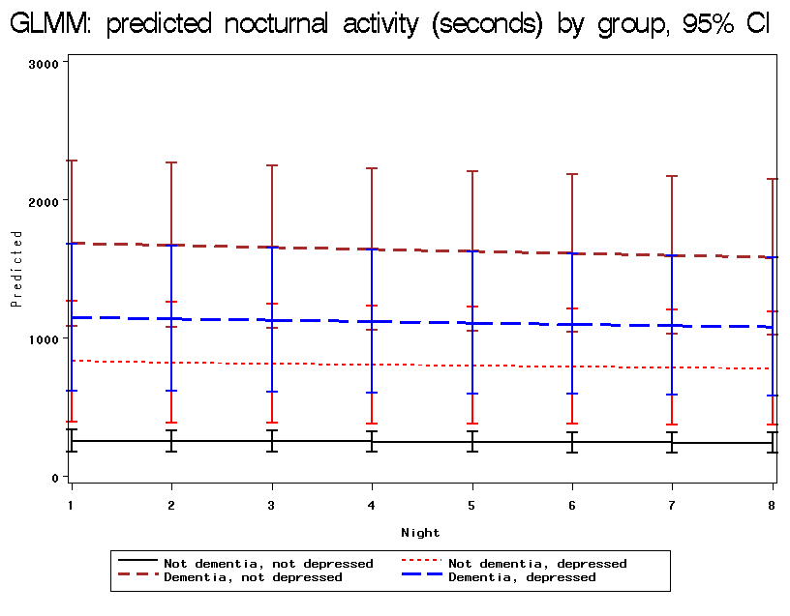

- ‘Dementia’ / ‘Not dementia’ in the legend is to denote the groups, ‘cognitively impaired’ / ‘normal cognitive function’, respectively.

Figure 4-6 shows predicted mean (GLMM) nocturnal activity (95% CI) by cognitive status
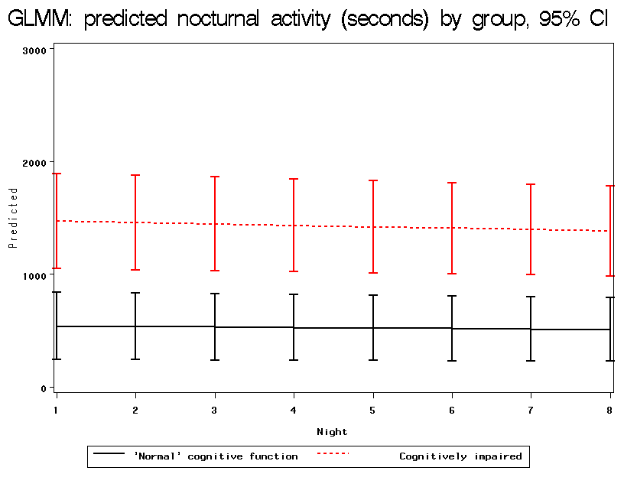

Table 4-4. Parameter estimates for the GLMM analysis by LINEARISATION method with nocturnal activity as outcome; N = 33
Characteristic | Gamma (random intercept) model  (restricted penalised quasi-likelihood) |  |  | Poisson (random slope) model  (restricted penalised quasi-likelihood)
Characteristic | Exponen. estimates | 95% CI | P-value | Exponen. estimates | 95% CI | P-value
Fixed-effects
Night | 0.99 | 0.96-1.02 | 0.54 | 0.99 | 0.96-1.02 | 0.60
Cognitive status  Cognitively impaired  Normal | 3.4  1.0 (referent) | 1.6-7.3 | <0.01 | 3.4  1.0 (referent) | 1.6-7.4 | <0.01
Depressed status  Yes  No | 2.6  1.0 (referent) | 1.0-6.6 | 0.05 | 2.6  1.0 (referent) | 1.0-6.7 | 0.04
ADL | 0.8 | 0.7-0.9 | 0.01 | 0.8 | 0.6-0.9 | 0.01
‘Depressed X cognitive’ status | 0.3 | 0.2-0.6 | 0.07 | 0.3 | 0.1-1.1 | 0.07
Intra-class correlation | 0.5
GOF (generalised X² / DF) | 0.7 |  |  | 593.6
Random-effects
Intercept variance | 0.678 | 0.274-1.082 | na | 0.945 | 0.439-1.451 | na
Intercept-slope covariance |  |  |  | -0.036 | -0.072-0.001 | na
Slope variance |  |  |  | 0.008 | 0.004-0.012 | na
Note: intra-class correlation coefficient and random-effects’ variance estimates are not exponentiated; values are rounded-off to one decimal value (except night and random-effects’ variance estimates)

- This analysis by linearisation method is done as a comparison to the main (numerical integration) analysis methods; however the results should be interpreted with caution here as this involves fitting the pseudo-data (cf. Molenberghs).
- Night (time) variable is not significant.
- Poisson model is kept only for comparison (AICc very high compared to the gamma or negative binomial model).
- Negative binomial parameter estimates (not shown) are very close to those of the gamma model (slightly better fit).
- The fixed-effects estimates of GLMM by numerical integration and linearisation are very similar, although the CIs with the latter method are narrower (less conservative).
- The random-effects estimates of GLMM by the linearisation method are estimated to be higher than those estimated by the numerical integration method.
- ‘empirical’, unstructured variance-covariance matrix options were employed to obtain parameter estimates.
- Residuals are a bit right skewed with no correlation between time-points (not shown).
- Graphical outputs are not presented, which are very similar to those of the GLMM numerical integration method.
- The GLIMMIX procedure does not fit hierarchical models with non-normal random effects. With the GLIMMIX procedure, one selects the distribution of the response variable conditional on (assumed) multivariate normally distributed random effects ~ (0, D). With increasing number of measurements per subject: (a) marginal quasi-likelihood remains biased, but (b) penalised quasi-likelihood is consistent. First order Taylor expansion is used to linearise the outcome into pseudo-data to fit the model, which runs way faster than numerical integration. This provides starting parameter values for numerical methods using SAS®.

Table 4-5. Parameter estimates by random splines method with nocturnal activity as outcome; N = 33
Characteristic | Negative binomial (random splines) model  Bucket size = 1000 |  |  | Poisson (random splines) model  Bucket size = 1000
Characteristic | Exponen. estimates | 95% CI | P-value | Exponen. estimates | 95% CI | P-value
Fixed-effects
Night | 0.98 | 0.89-1.10 | 0.78 | 0.88 | 0.87-0.90 | <0.01
Cognitive status  Cognitively impaired  Normal | 4.1  1.0 (referent) | 2.1-7.9 | <0.01 | 6.7  1.0 (referent) | 6.3-7.1 | <0.01
Depressed status  Yes  No | 2.9  1.0 (referent) | 1.3-6.2 | <0.01 | 5.7  1.0 (referent) | 5.4-6.1 | <0.01
ADL | 0.8 | 0.7-0.9 | <0.01 | 0.7 | 0.7-0.7 | <0.01
‘Depressed X cognitive’ status | 0.3 | 0.1-0.8 | 0.02 | 0.2 | 0.2-0.2 | <0.01
Dispersion parameter | 0.8 | 0.6-1.0 | na
GOF (generalised X² / DF) | 1.0 |  |  | 569.6
Random-effects
Random splines variance | 0.007 | 0.004-0.010 | na | 0.016 | 0.010-0.021 | na
No. of knots & knots position | 1,8 |  |  | 1,8
Note: dispersion parameter and random-effects’ variance estimates are not exponentiated; values are rounded-off to one decimal value (except night and random-effects’ variance estimates)

- Night (time) variable is not significant.
- Poisson model is kept only for comparison (loglikelihood very high compared to the negative binomial model).
- Gamma model did not converge upon 1000 iterations.
- A key factor in the specification of the spline-based method is the so-called bucket size, a tool to determine the knots. Larger bucket sizes implies less knots, and vice versa (cf. Molenberghs).
- The SEs in the smoothing based models are smaller than the GLMM models, illustrating that a more refined association structure had led to increased precision. The variance of the random spline coefficients is relatively small, but highly significant nevertheless, underscoring the point that a considerable improvement of model fit is obtained in this way.
- The random smoothing splines are invoked by calling the RANDOM statement, with time as the random-effect and then the ‘type = rsmooth’ option; k-d tree method = nearest neighbour method.
- There is a difference with classical spline fitting since in this approach the spline coefficients are random-effects, whereas they are fixed-effects in a classical approach.
- The SAS procedure GLIMMIX uses radial base functions and transforms them to approximate a thin-plate spline.
- Where spl_{i}(t_{ij}) is a random smoothing spline in time, instead of a random intercept b_{i}. Clearly, an association is induced by the inclusion of such random splines, in analogy with the inclusion of conventional random effects.
- Residuals are a bit right skewed with no correlation between time-points (not shown).

Figure 4-7 shows predicted mean (random splines) nocturnal activity (95% CI) by ‘depressed status X cognitive status’
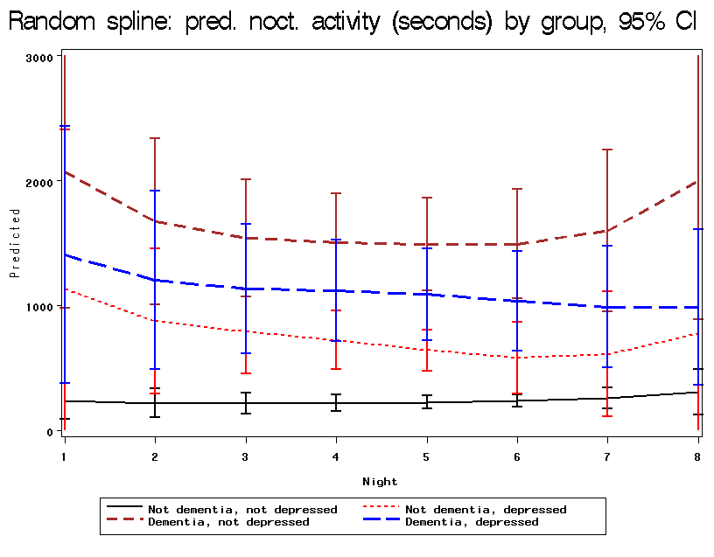

- ‘Dementia’ / ‘Not dementia’ in the legend is to denote the groups, ‘cognitively impaired’ / ‘normal cognitive function’, respectively.

Figure 4-8 shows predicted mean (random splines) nocturnal activity (95% CI) by cognitive status
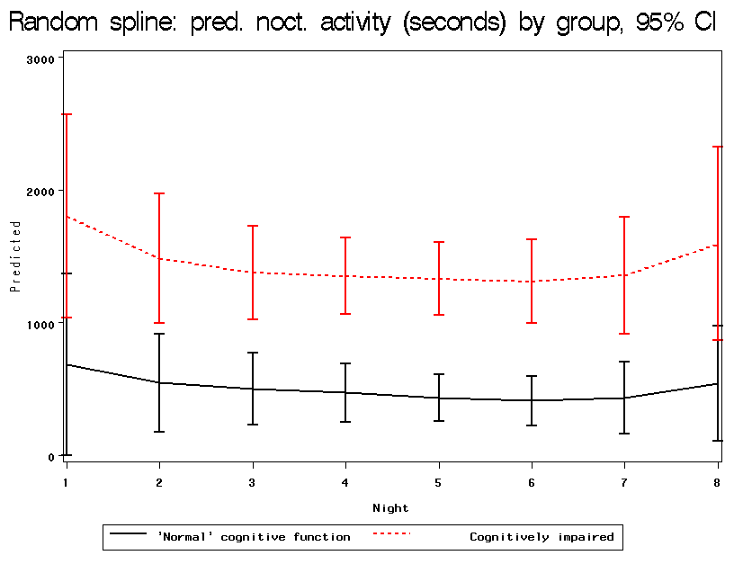

Comparison of two subpopulations with and without depressed status

Univariate:
Patients not having (N = 11) and having (N = 33) the depressed variable were compared (Kruskal-Wallis or Fisher 2-tailed test) in terms of population characteristics in separate univariate analyses. The variables that were compared: MMSE, ADL, prosthesis, antidepressants, neuroleptics, hypnotics, continence, weight and mean nocturnal activity (outcome). None of these variables were significantly different between the two groups. One patient who did not have any covariate was excluded in this analysis.

Multivariate:
In addition, all these variables (not outcome) were entered in a multiple logistic regression model to estimate the probability of having to not having the missing depressed variable explained by these variables using stepwise backward elimination. Again, none of the variables were retained in the final model. One patient who did not have any covariate was excluded in this analysis.

Appendix

Table 6-6. Demographic & clinical characteristics of the sample population by exposure group; N = 33
Characteristics | Cognitively impaired  (N = 25) | Normal cognitive function  (N = 8) | P-value
MMSE, mean (SD)* | 14.0 (5.0) | 26.6 (1.2) | <0.01
ADL, mean (SD)* | 3.5 (1.4) | 4.7 (1.4) | 0.04
Weight, mean (SD)* | 57.8 (9.5)† | 60.8 (14.8) | 0.82
Mean nocturnal activity (seconds), mean (SD)* | 1593.3 (1393.2) | 548.2 (536.8) | 0.04
Disability, N (%)‡  ADL ≤3  ADL >3 | 10 (40.0)  15 (60.0) | 1 (12.5)  7 (87.5) | 0.22
Depressed, N (%)‡  Yes  No | 10 (40.0)  15 (60.0) | 4 (50)  4 (50) | 0.70
Prosthesis, N (%)‡  Yes  No | 4 (16.7)§  20 (83.3) | 3 (37.5)  5 (62.5) | 0.33
Hypnotics, N (%)‡  Yes  No | 21 (84.0)  4 (16.0) | 5 (62.5)  3 (37.5) | 0.32
Antidepressants, N (%)‡  Yes  No | 10 (41.7)§  14 (58.3) | 3 (37.5)  5 (62.5) | 1.00
Neuroleptics, N (%)‡  Yes  No | 14 (58.3)§  10 (41.7) | 1 (12.5)  7 (87.5) | 0.04
Continence, N (%)‡  Incontinent  Partially incontinent  Continent | 2 (8.0)  11 (44.0)  12 (48.0) | 1 (12.5)  0 (0.0)  7 (87.5) | 0.04
* Kruskal-Wallis test
† N = 23
‡ Fisher test
§ N = 24

- Other characteristics need to be filled like age, gender, etc. A table on the actual diagnoses of the patients should be provided.
- This should be the first table in the ‘results’ section of the manuscript.
- For the outcome, mean ≈ standard deviation, in which case a log transformation of the outcome is often recommended, but this approach is abandoned in favour of more flexible GLM and ease of interpretation of parameter estimates in the latter.

Figure 6-9 shows model fit graphs for the cross-sectional analysis
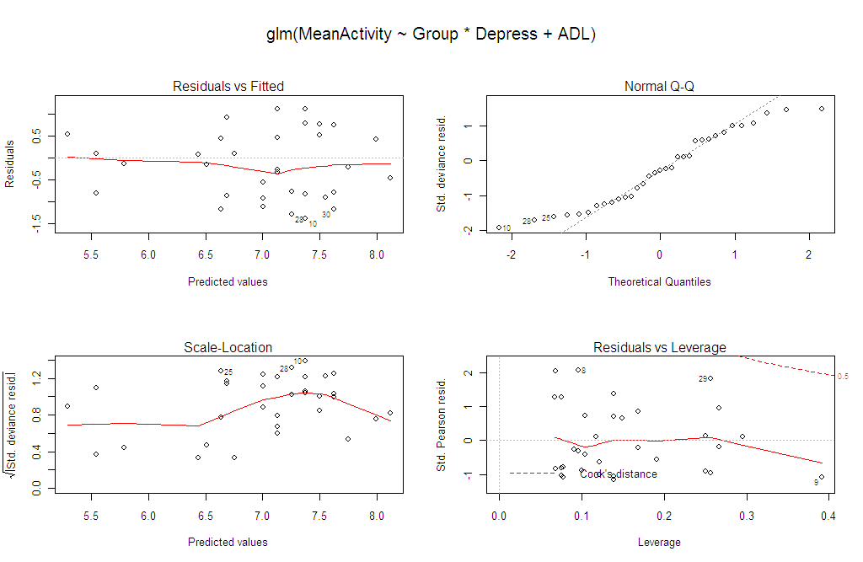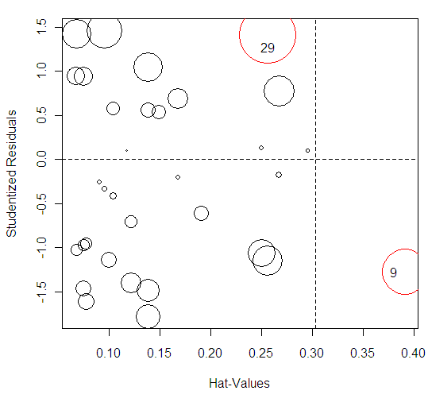

Figure 6-10 shows covariates’ effects plots for the cross-sectional analysis
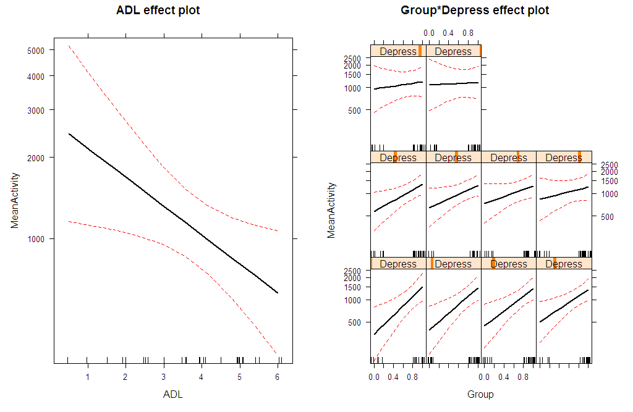

Figure 6-11 shows scatterplot matrix between ADL, MMSE and mean nocturnal activity for the cross-sectional analysis
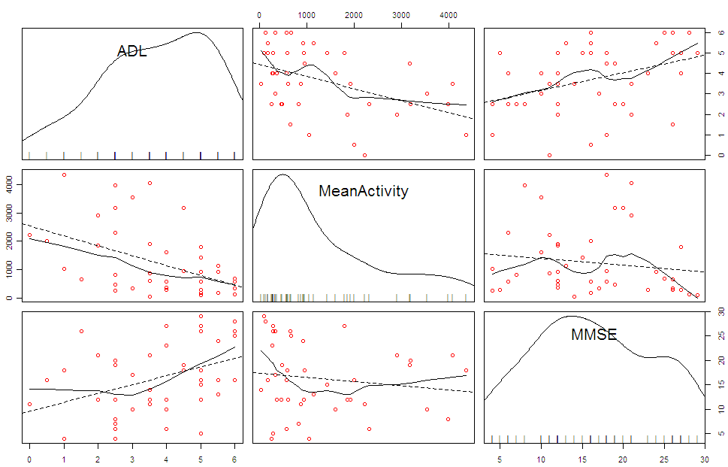

- N = 45 (full data set).

Figure 6-12 shows boxplots of observed nocturnal activity by different groups for the cross-sectional analysis
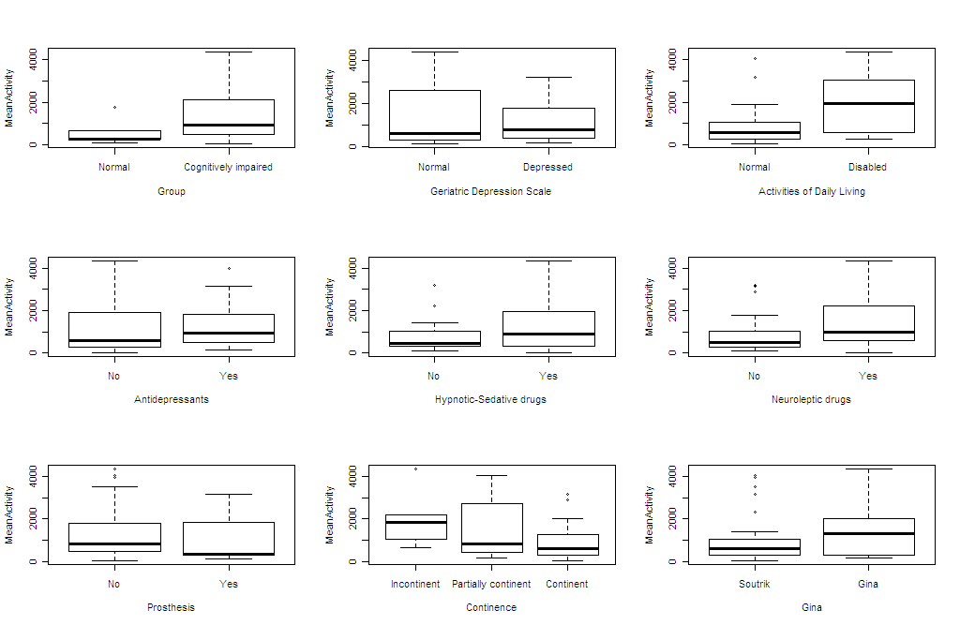

- N = variable (i.e., 33 to 45 according to missing covariates).

Figure 6-13 shows night1 – night8 scatterplot matrix of observed nocturnal activity for the longitudinal analysis
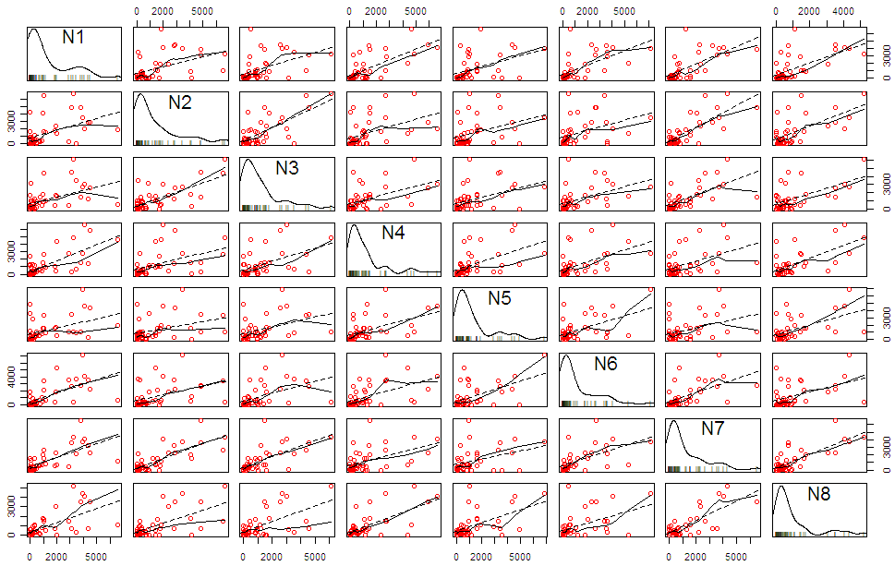

- Some degree of correlation is observed between the repeated measures’ outcomes, but no apparent pattern, such as decreasing correlation with time, is noted.
- N = 45 (full data set).

Figure 6-14 shows the evolution of individual observations (after standardising) over 8 nights for the longitudinal analysis
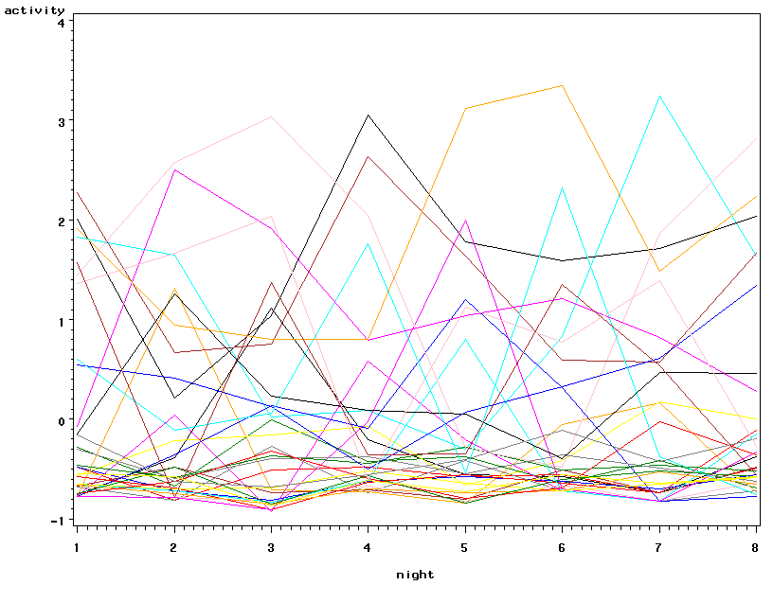

- ‘Tracking’ phenomenon can be observed by visual inspection.

Figure 6-15 shows the boxplots of observed nocturnal activity by cognitive status over 8 nights for the longitudinal analysis
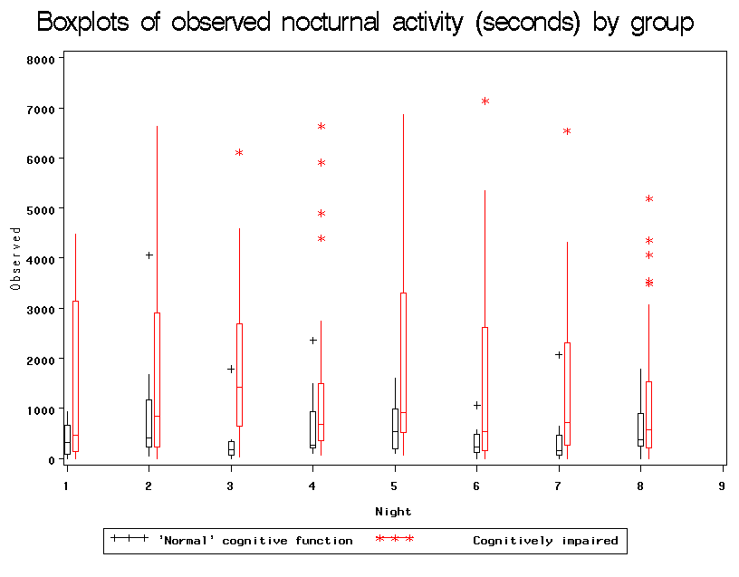

- Distribution appears to be heavily right skewed in the cognitively impaired group.

Figure 6-16 shows the average (95% CI) observed evolution by ‘depressed status X cognitive status’ for the longitudinal analysis
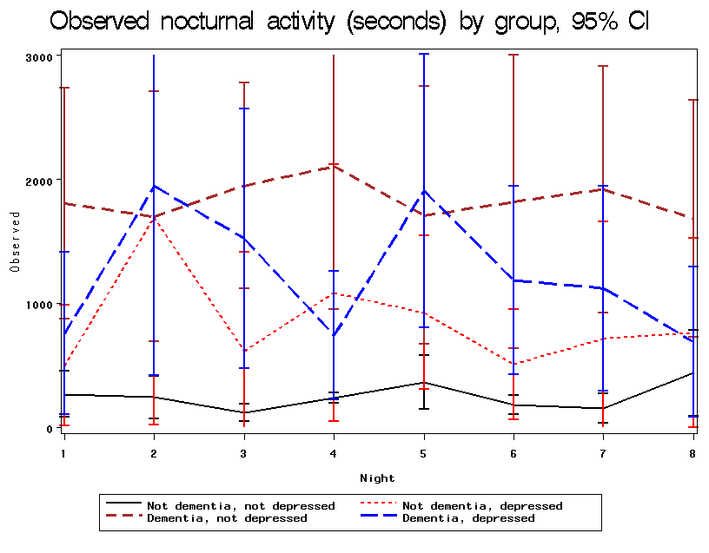

- ‘Dementia’ / ‘Not dementia’ in the legend is to denote the groups, ‘cognitively impaired’ / ‘normal cognitive function’, respectively.

Figure 6-17 shows the average (95% CI) observed evolution by cognitive status for the longitudinal analysis
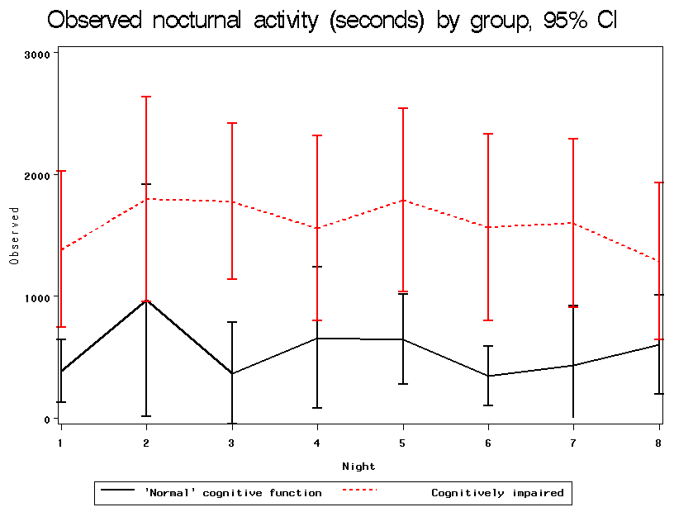

Figure 6-18 shows the qqplot (95% CI) of empirical Bayes (random-intercept) estimates for the longitudinal analysis
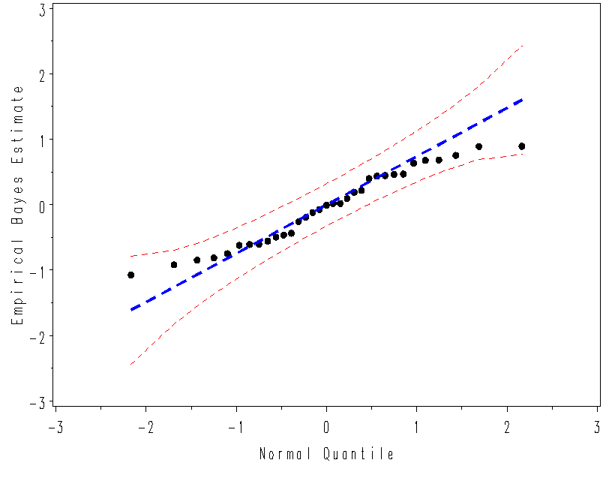

- Negative binomial (random-intercept) model using numerical integration method (check of model fit).
- Estimated random-intercepts do not deviate from the normality assumption. However, this does not prove normality of the random-effects.

Figure 6-19 shows night1 – night8 scatterplot matrix of residuals (random-intercept) for the longitudinal analysis
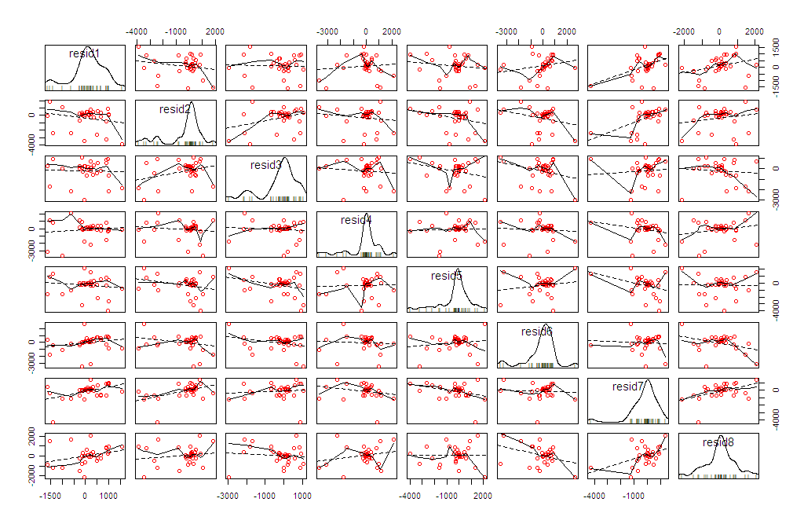

- Negative binomial (random-intercept) model using numerical integration method (check of model fit).
- Heavy (esp. left) tails can be observed of the residuals.

Figure 6-20 shows the boxplots of residuals (random-intercept) by cognitive status over 8 nights for the longitudinal analysis
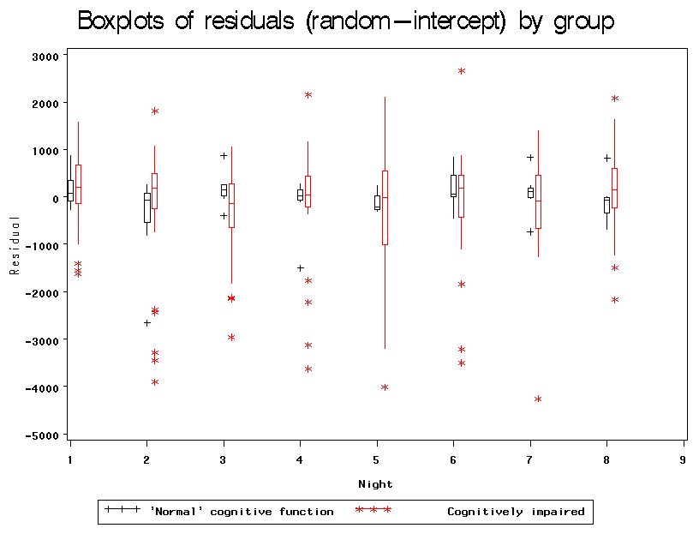

- Negative binomial (random-intercept) model using numerical integration method (check of model fit).
- Heavy (esp. left) tails can be observed of the residuals, particularly in the cognitively impaired group.

Table 6-7 shows the posterior probabilities and parameter estimates of a 2-component Gaussian mixture analysis using the R-packages FlexMix (or Mclust), CAMAN & mixtools, & WinBUGS for the cross-sectional analysis
Frequentist
FlexMix / Mclust |  |  | CAMAN / mixtools (equal variance) |  |  | mixtools (unequal variance)
Posterior probability | N | Mean (SD) in seconds | Posterior probability | N | Mean (SD) in seconds | Posterior probability | N | Mean (SD) in seconds
0.67 | 22 | 504 (271) | 0.78 | 26 | 726 (551) | 0.78 | 26 | 740 (595)
0.33 | 11 | 2,801 (1,074) | 0.22 | 7 | 3,572 (551) | 0.22 | 7 | 3,520 (644)

Bayesian (WinBUGS)
Equal variance |  |  | Unequal variance
Posterior probability | N | Mean (SD) in seconds | Posterior probability | N | Mean (SD) in seconds
0.75 | 25 | 739 (610) | 0.58 | 19 | 494 (269)
0.25 | 8 | 3,335 (610) | 0.42 | 14 | 2,345 (1,294)

- FlexMix derived separate variance parameters for each component (two components finally starting from 5 components). The BIC value was slightly lower than that of the CAMAN fitted model (see next bullet point); therefore, this model maybe a trifle better than the CAMAN model (however, the total variance of the CAMAN fitted model was closer to the total data variance than the total variance of the FlexMix fitted model).
- CAMAN derived a single variance parameter for both components. A starting value of 10 components was used using VEM algorithm, which gave a final mixture of two components. A mixture distribution was refitted with two components using EM algorithm.
- To note that CAMAN, Mclust & ?mixtools do not allow component mixture model on repeated measures data unlike FlexMix.
- Mclust also gave very similar estimates like that obtained with FlexMix.
- Post-hoc (without specifying the no. of components): mixtools gave separate variance parameters (although they were quite close in value) for each component; however fit statistics could not be obtained in this case ??? It would have been interesting to see the improvement over CAMAN (and also FlexMix) if the fit statistics were obtained. Using another fitting method by mixtools giving a single variance parameter, it gave very close estimates like that obtained with CAMAN.
- Finally, another post-hoc anlaysis using WinBUGS with the no. of components equal to two, which was inspired from the frequentist analysis and using both single and separate variance parameters were fitted.
- To note that fitting Poisson component mixture models gave warnings with both FlexMix & CAMAN. The R-packages Mclust & mixtools do not permit Poisson component mixture models.
- The main idea behind component mixture analysis was to determine any measured variable that distinguishes the components, i.e., “pacers” from “non-pacers” (cf. Satlin et al., 1991, who compared these two categories’ wandering in AD classified by nurses’ impression). This will be the next step in the cross-sectional analysis only.
- Remark: based on the results of the fitted component mixture model on the longitudinal data (vide the page after next), it appears that a cut-off of 26/7 patients into two groups could have been used to fit a logistic model to be consistent in classification for both the cross-sectional and longitudinal models (with the first three components coalesced into one here). However, based only on the slightly better fit in the cross-sectional model, a cut-off of 22/11 patients was preferred to fit a logistic model compared to a cut-off of 26/7 patients, although the latter cut-off could well be tried as a sensitivity analysis. No fitting (ordinal / binary outcomes) was performed for longitudinal data.

Figure 6-21 shows the histogram of mean nocturnal activity (seconds) overlaid with two 2-component Gaussian finite mixture models using the R-packages FlexMix, Mclust, CAMAN & mixtools, & WinBUGS for the cross-sectional analysis
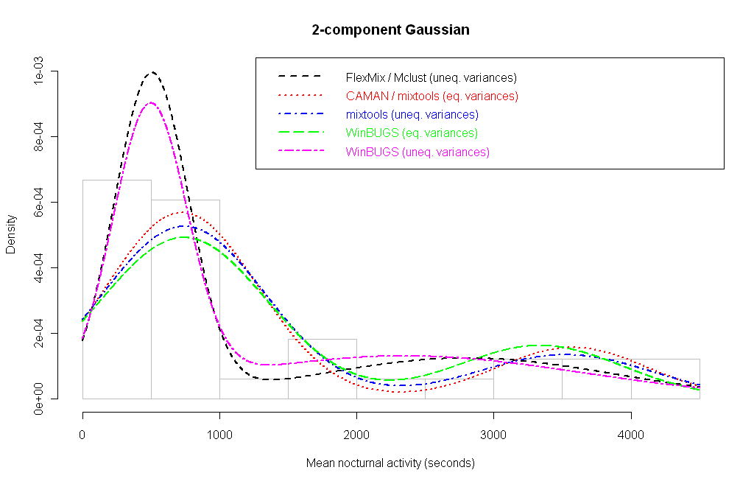

Table 6-8 shows the posterior probabilities and parameter estimates of a 4-component Gaussian mixture analysis using the R-package FlexMix for the longitudinal analysis
FlexMix
Posterior probability | N | Mean (SD) in seconds
0.21 | 7 | 244 (159)
0.24 | 8 | 486 (340)
0.33 | 11 | 1193 (1250)
0.22 | 7 | 3498 (1738)

Figure 6-22 shows the histogram of nocturnal activity (seconds) overlaid with 4-component Gaussian finite mixture models using the R-package FlexMix and smoothed kernel density for the longitudinal analysis

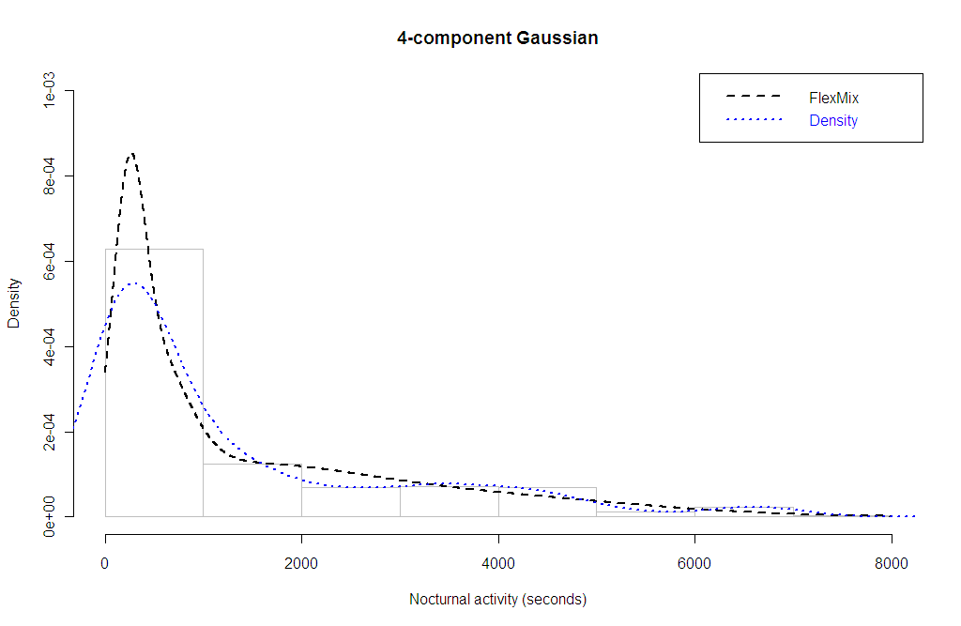

Figure 6-23 shows the predicted probability of being a ‘pacer’ to a ‘non-pacer’ by ADL for the cross-sectional analysis
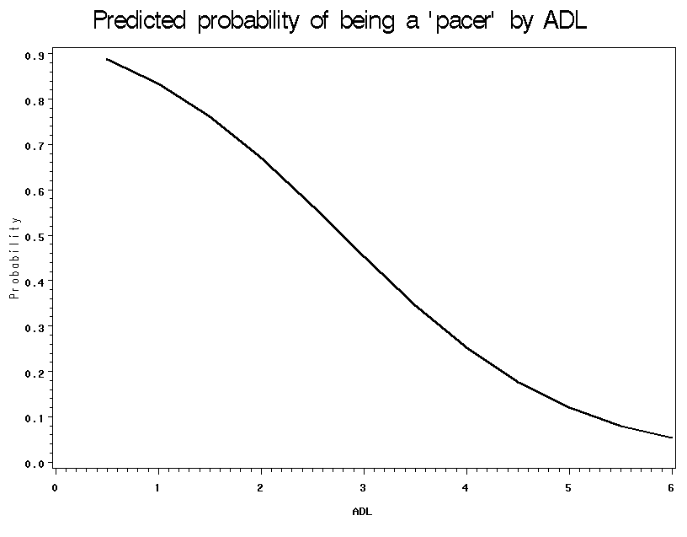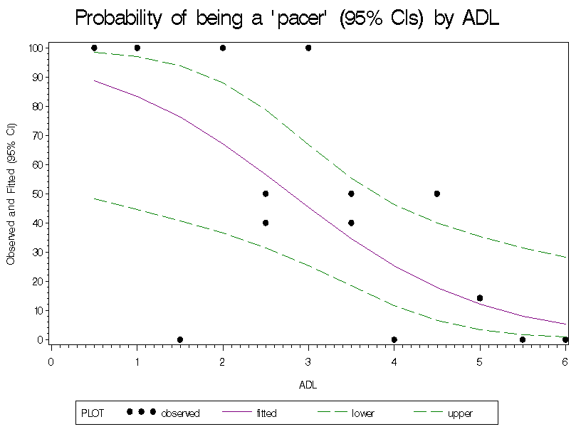

- A logistic regression model was fitted based on the results of finite mixture analysis to identify the determinant of being a ‘pacer’ (= high mean nocturnal activity, >1700 seconds) to a ‘non-pacer’ (low mean nocturnal activity) in the given sample population of elderly inpatients with varying levels of cognitive function loss. The fit statistics were good, except 1 serious outlier.
- In the right figure, a black dot may be derived from more than one individual having same probabilities.
- A backward elimination procedure was applied with variables: cognitive status, depressed status, interaction ‘cognitive X depressed’ status, ADL, prosthesis, antidepressants, neuroleptics, hypnotics, continence and weight. Only ADL was retained in the final model showing an inverse relationship with the predicted probability of being a “pacer”; OR = 0.4 (0.2-0.8, 95% CI; p <0.01). This translates to odds of being a “pacer” decreases by 0.4 times with each unit rise in ADL score.

Conclusion
The main conclusions from this study are:
- Highly right skewed distribution of the nocturnal activity; mean nocturnal activity proportional to standard deviation.
- Significant overdispersion is present in the outcome. Due to this nature of the data, models with Poisson distribution fitted poorly. Notwithstanding, gamma or negative binomial distribution yielded good fit and provided similar parameter estimates in both cross-sectional and longitudinal data.
- No effect of time or interaction between time and another covariate in the short-term evolution (1 week) of the patients.
- Although there is correlation among the repeated measures, but it is estimated to be constant across different time points, i.e., the compound symmetry or exchangeability condition.
- While fitting hierarchical parametric models, a random-intercept model was found to be satisfactory, meaning that conditional on baseline heterogeneity, the evolution is parallel for the individuals, i.e., no fanning or regression to the mean with time.
- ADL, cognitive and depressed status being the significant predictors of nocturnal activity. Interaction between cognitive and depressed status.
- ADL, not cognitive or depressed status, is the lone significant predictor (among measured variables) on the probability of being a “pacer”.

Bayesian analysis using MCMC sampling
Table 8-9. Parameter estimates for the cross-sectional analysis with mean nocturnal activity as outcome; N = 33
Characteristic | Bayesian (Poisson) |  |  | Frequentist (Poisson)
Characteristic | Exponentiated estimates | 95% CrI | Exponentiated estimates |  | 95% CI | P-value
Cognitive status  Cognitively impaired  Normal | 4.6  1.0 (referent) | 4.3-4.9 | 4.6  1.0 (referent) |  | 4.3-4.9 | <0.01
Depressed status  Yes  No | 2.7  1.0 (referent) | 2.5-2.9 | 2.7  1.0 (referent) |  | 2.5-2.9 | <0.01
ADL | 0.8 | 0.8-0.8 | 0.8 |  | 0.8-0.8 | <0.01
‘Depressed X cognitive’ status | 0.3 | 0.3-0.3 | 0.3 |  | 0.3-0.3 | <0.01
GOF (value / DF) |  |  | 851.4
Note: values are rounded-off to one decimal value

- The Bayesian model fit is not good; the predicted values are quite different from the observed. DIC = 23,761.0, pD = 5.
- The frequentist model fit is not good as seen from the GOF (high overdispersion).
- The Bayesian (median, 95% CrIs) and frequentist (mean, 95% CIs) parameter estimates are very close.
- The Bayesian model convergence: MCMC error <5% of SEs, BGR statistics are close to 1 (other statistics of the posterior distribution not shown).

Table 8-10. Parameter estimates for the cross-sectional analysis with mean nocturnal activity as outcome; N = 33
Characteristic | Bayesian (Gamma-Poisson) |  |  | Frequentist (Negative binomial)
Characteristic | Exponentiated estimates | 95% CrI | Exponentiated estimates |  | 95% CI | P-value
Cognitive status  Cognitively impaired  Normal | 4.1  1.0 (referent) | 1.4-10.9 | 4.3  1.0 (referent) |  | 1.7-10.9 | <0.01
Depressed status  Yes  No | 3.1  1.0 (referent) | 1.0-10.2 | 3.1  1.0 (referent) |  | 1.1-8.8 | 0.03
ADL | 0.8 | 0.6-1.0 | 0.8 |  | 0.6-1.0 | 0.02
‘Depressed X cognitive’ status | 0.3 | 0.1-1.0 | 0.3 |  | 0.1-0.8 | 0.02
Scale/dispersion parameter | 1.6 | 1.0-2.5 | 0.6 |  | 0.3-0.8 | na
GOF (value / DF) |  |  | 0.7
Note: scale/dispersion parameter is not exponentiated; values are rounded-off to one decimal value

- The Bayesian model fit is good; the predicted values are close to the observed. DIC = 348.0, pD = 33.
- The frequentist model fit is good as seen from the GOF.
- The Bayesian (median, 95% CrIs) and frequentist (mean, 95% CIs) parameter estimates are quite similar.
- The Bayesian model convergence: MCMC error <5% of SEs, BGR statistics are close to 1 (other statistics of the posterior distribution not shown).

Table 8-11. Parameter estimates for the GLMM analysis by NUMERCIAL INTEGRATION method with nocturnal activity as outcome; N = 33
Characteristic | Bayesian (Poisson (random slope)) |  | Frequentist (Poisson (random slope))
Characteristic | Exponentiated estimates | 95% CrI | Exponentiated estimates | 95% CI |  | P-value
Fixed-effects
Night | 0.99 | 0.96-1.02 | 0.99 | 0.96-1.02 | 0.60
Cognitive status  Cognitively impaired  Normal | 3.6  1.0 (referent) | 1.1-11.2 | 3.4  1.0 (referent) | 1.2-9.4 | 0.02
Depressed status  Yes  No | 2.7  1.0 (referent) | 0.7-11.1 | 2.6  1.0 (referent) | 0.7-8.8 | 0.13
ADL | 0.8 | 0.6-1.0 | 0.8 | 0.6-1.0 | 0.04
‘Depressed X cognitive’ status | 0.3 | 0.1-1.5 | 0.3 | 0.1-1.3 | 0.12
Random-effects
Intercept variance | 1.073 | 0.388-3.621 | 0.822 | 0.388-1.256 | <0.01
Intercept-slope covariance | -0.001 | -0.008-4.5E-07 | -0.035 | -0.069-4.1E-04 | 0.05
Slope variance | 0.009 | 0.005-0.015 | 0.008 | 0.004-0.012 | <0.01
Note: random-effects’ variance estimates are not exponentiated; values are rounded-off to one decimal value (except night and random-effects’ variance estimates)

- The Bayesian model fit is not good; the predicted values are close to the observed. DIC = 153,294.0, pD = 66.
- The frequentist model fit is not good (loglikelihood).
- The Bayesian (median, 95% CrIs) and frequentist (mean, 95% CIs) fixed & random-effects parameter estimates are quite similar.
- The Bayesian model convergence: MCMC error <5% of SEs, BGR statistics are close to 1 (other statistics of the posterior distribution not shown).

Table 8-12. Parameter estimates for the GLMM analysis by NUMERCIAL INTEGRATION method with nocturnal activity as outcome; N = 33
Characteristic | Bayesian (Gamma-Poisson (random intercept)) |  | Frequentist (Negative binomial (random intercept))
Characteristic | Exponentiated estimates | 95% CrI | Exponentiated estimates | 95% CI |  | P-value
Fixed-effects
Night | 0.99 | 0.93-1.06 | 0.99 | 0.92-1.06 | 0.80
Cognitive status  Cognitively impaired  Normal | 3.5  1.0 (referent) | 1.2-10.4 | 3.4  1.0 (referent) | 1.3-9.4 | 0.02
Depressed status  Yes  No | 2.7  1.0 (referent) | 0.7-9.3 | 2.6  1.0 (referent) | 0.8-8.5 | 0.10
ADL | 0.8 | 0.6-1.0 | 0.8 | 0.6-1.0 | 0.02
‘Depressed X cognitive’ status | 0.3 | 0.1-1.4 | 0.3 | 0.1-1.3 | 0.10
Scale/dispersion parameter | 0.8 | 0.7-0.9 | 0.7 | 0.6-0.8 | <0.01
Random-effects
Intercept variance | 0.602 | 0.300-1.210 | 0.456 | 0.125-0.788 | <0.01
Note: scale/dispersion parameter and random-effects’ variance estimates are not exponentiated; values are rounded-off to one decimal value (except night and random-effects’ variance estimates)

- The Bayesian model fit is good; the predicted values are close to the observed. DIC = 2,596.6, pD = 255.
- The frequentist model fit is good (loglikelihood).
- The Bayesian (median, 95% CrIs) and frequentist (mean, 95% CIs) fixed & random-effects parameter estimates are quite similar.
- The Bayesian model convergence: MCMC error <5% of SEs, BGR statistics are close to 1 (other statistics of the posterior distribution not shown).

Figure 8-24 shows simulated gamma PDFs and CDFs of the full data (N = 45) by two exposure groups, respectively for the cross-sectional analysis
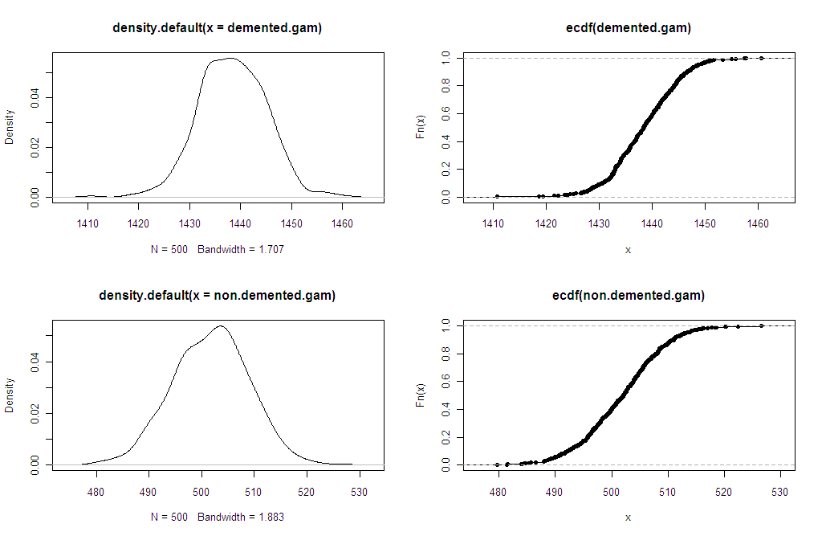

Figure 8-25 shows the posterior parameter distributions (gamma) and posterior predictive distributions (negative binomial) of the full data (N = 45) by two exposure groups, respectively for the cross-sectional analysis
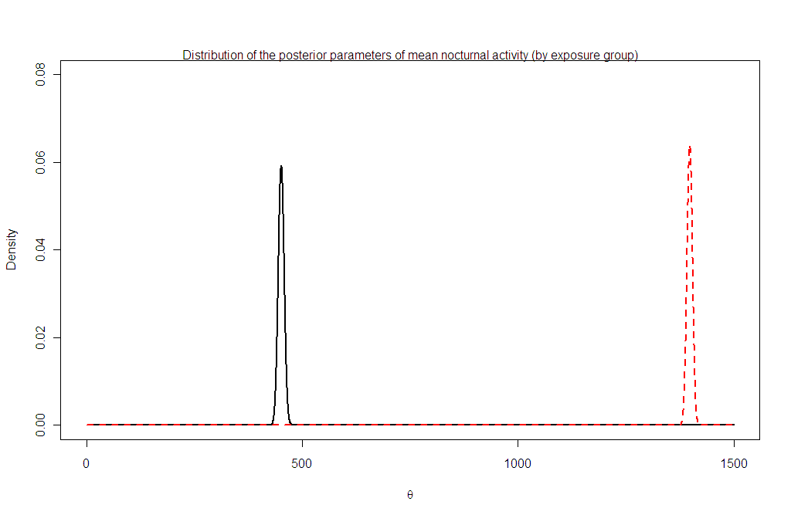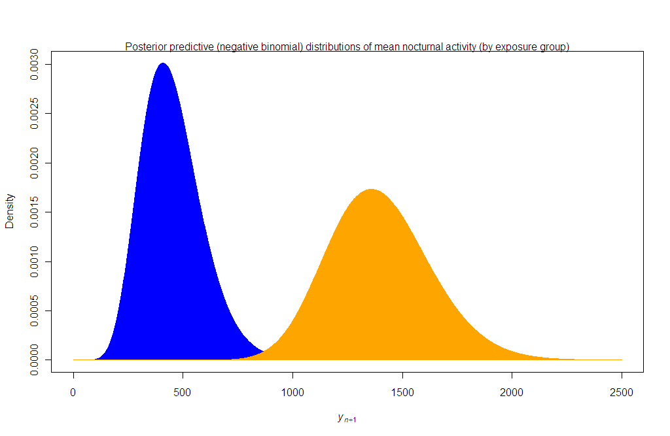

Figure 8-26 shows the posterior density of a mixture of 2 normal distributions using MCMC with the R-package mixAK for the cross-sectional analysis
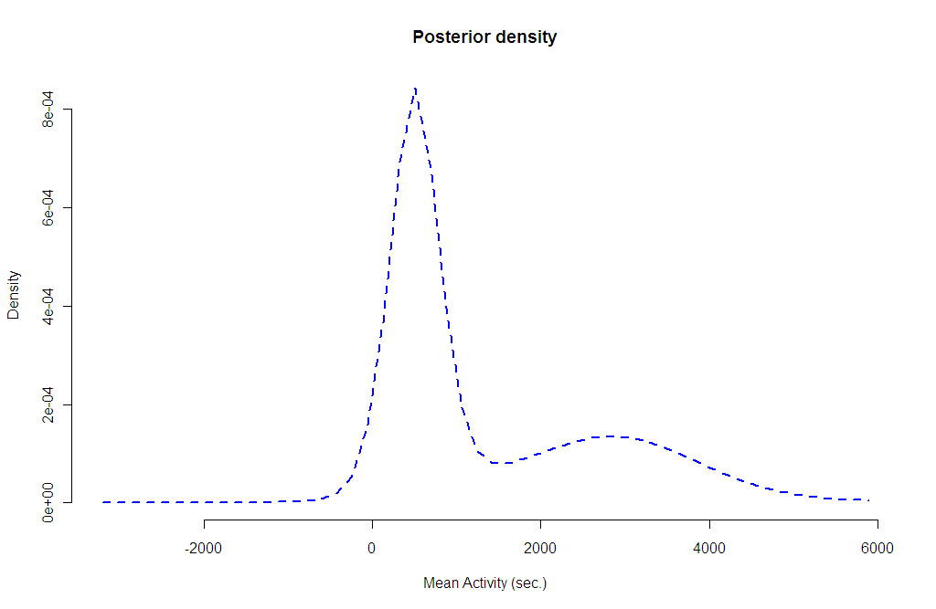

The 2 components here were pre-fixed; they were inspired from the previous frequentist analysis (Table 6-7).

